CentOS Virtual Machine

4 (a). Objdump used to list shared object libraries.

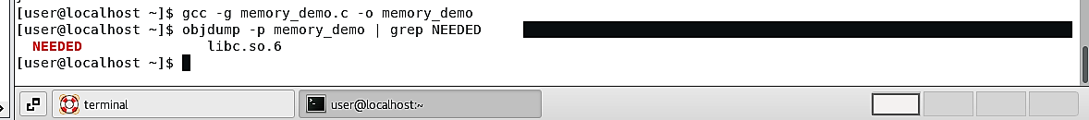

4 (b). ldd to see a list of shared object libraries before executing compiled program.

4 (c). Inspect all memory section header.

4 (d). Disassembling compiled machine code to make it more readable. Using objdump -d.

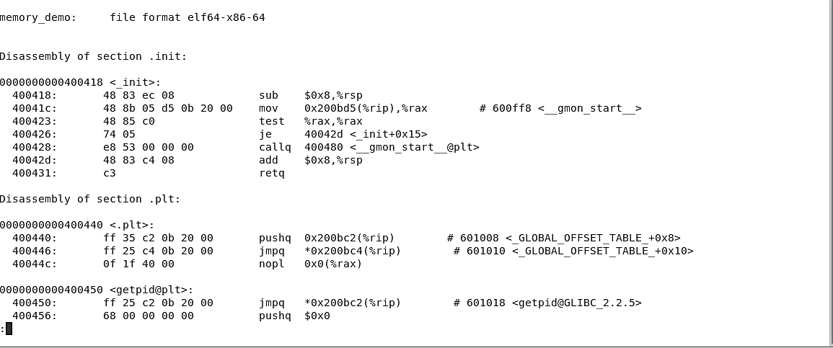

4 e. ‘hexdump -C memory_demo | less’ command to display hexadecimal contents of the file



5. Results of ‘size’ command

6. Results of ‘readelf -h memory_demo’.

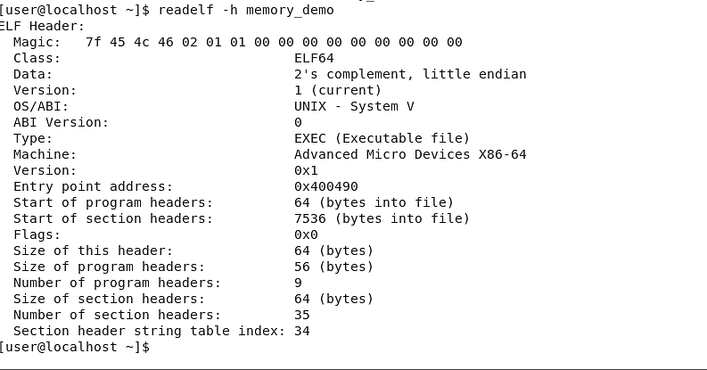

7. I located the actual shared object files by running the ldd memory_demo and objdump -p commands. Then, I determined that /lib64/ had the files. I used cd command to change directory to the desired one (cd /lib64). Then I used the ls command to list the shared files in the directory lib64.

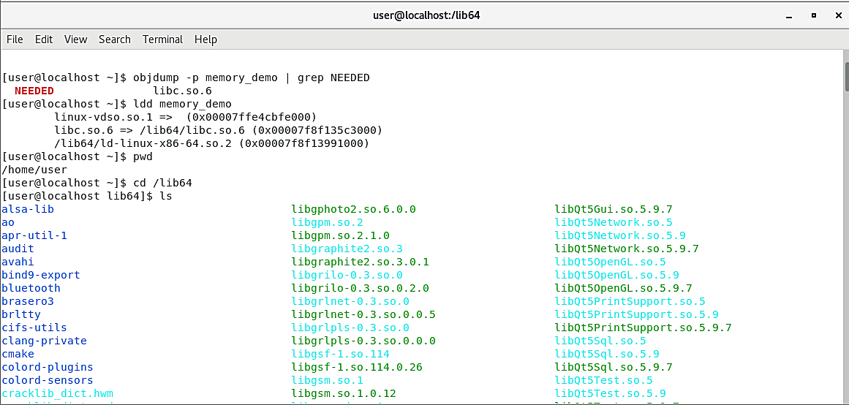

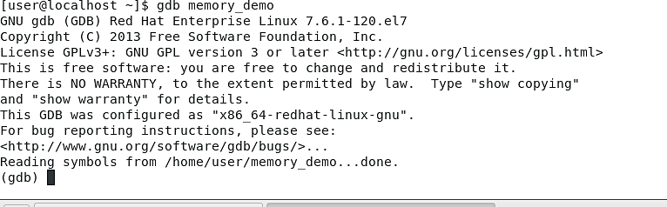8. Using ‘gdb’ to debug the program.

9. Listing the main function.

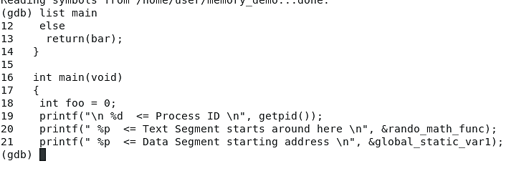

10. Disassemble rando_math_func.

11. Setting a breakpoint then running/executing the program inside the debugger until it hits the breakpoint (using r command).

12. Inspecting the registers. The rsp (highlighted) refers to the Stack Pointer value and the rbp (circled) refers to the Base Pointer value. The stack pointer value points to the top of the current stack frame while the base pointer refers to the base of the current stack frame.

13. Inspecting the context of the current frame.

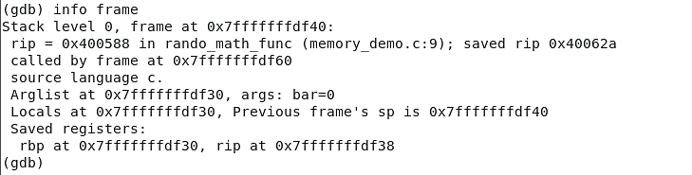13 (b). Continuing execution then hitting the same breakpoint again. Doing a second info frame.

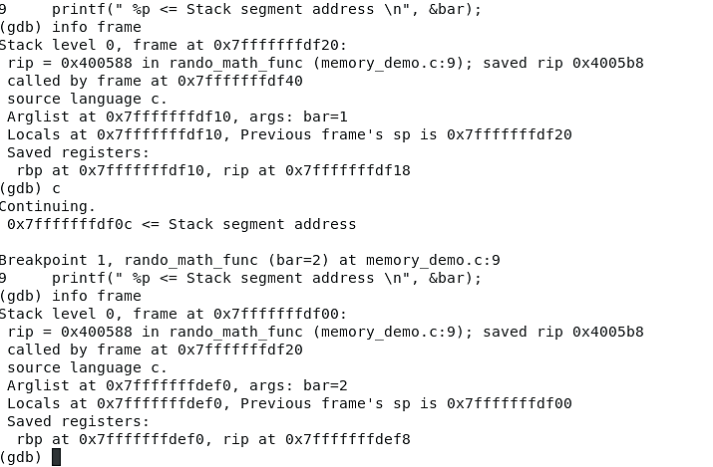

14. Disassembling code near ‘saved rip’ address.

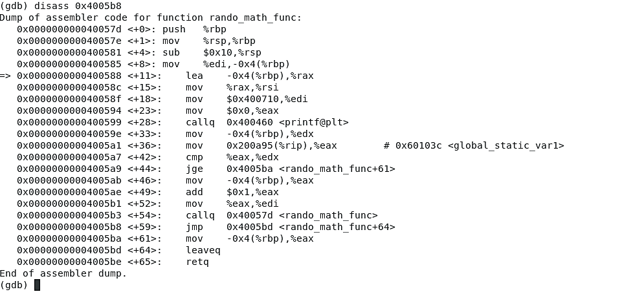

15. Exploring ‘info args’ through two iterations.

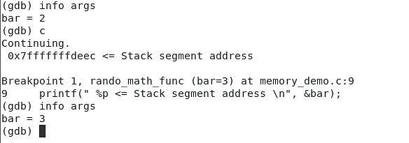

Windows Server 2019

4. Obtaining a process list in the SysInternalsSuite directory. The process ID of the Isass process is 828 (highlighted).

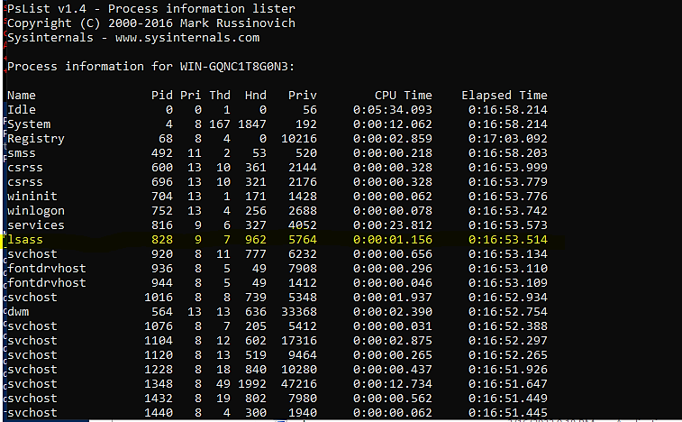

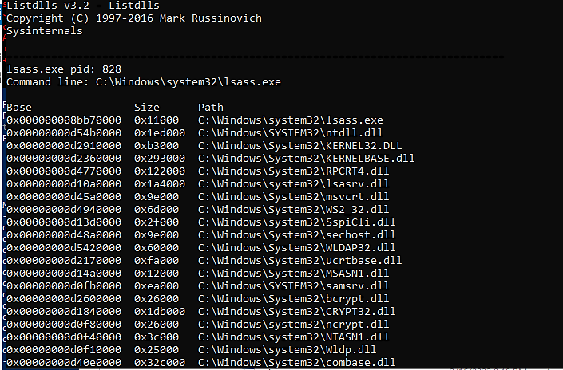5. Isass.exe mapped DLLs.

7. Screenshot of VMMap. The memory marked for “Execute/Read” permissions is found under the Protection column in the bottom window and is under Type “Image”.

